Windows Movie Maker Basics

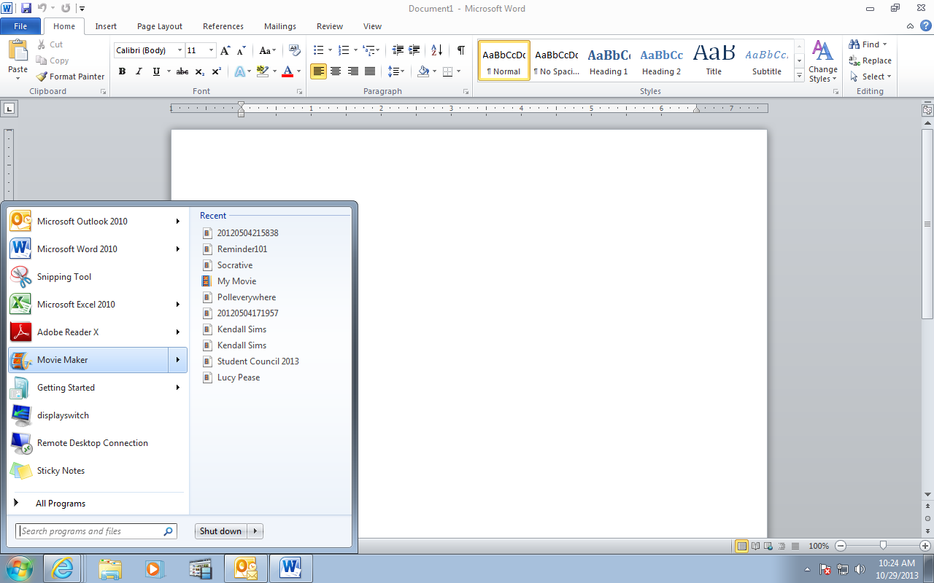

Movie Maker is on all our laptops and computers.



This is a new Movie Maker project.

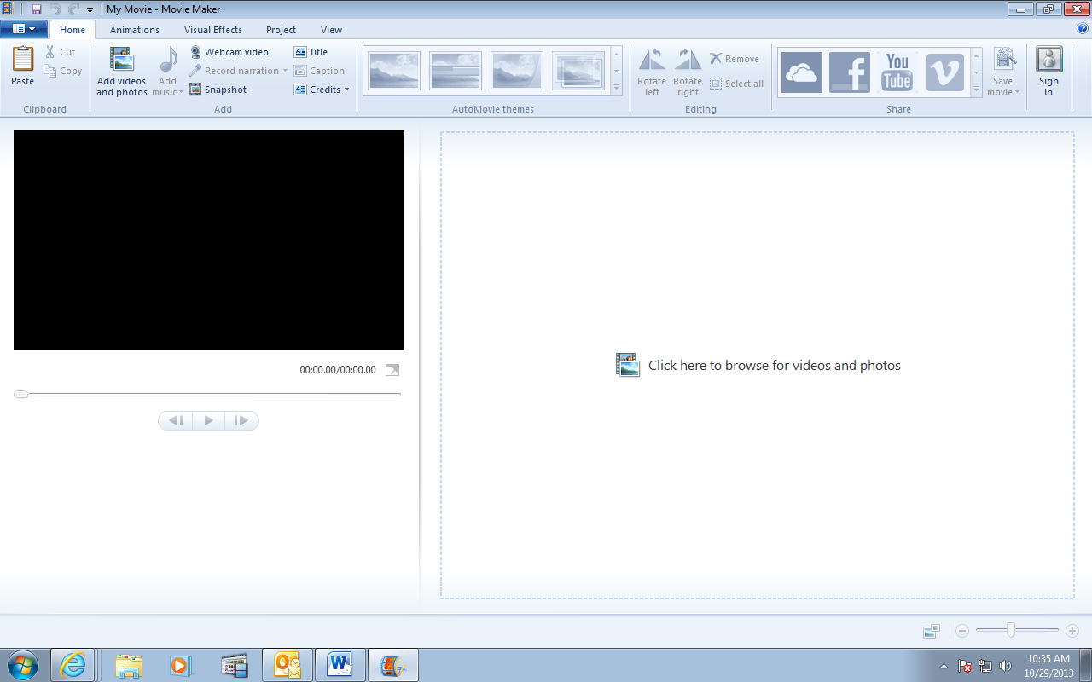

**Importing videos and pictures**

After you’ve opened a new Movie Maker project, you’ll need to import the videos and pictures you want to use. Make sure you know where the video files and pictures you want to use are on your computer, because when you go to import them you will need to easily find them on your computer.

* Click File and then click Import Media Items.
* Navigate to the location that contains the digital media files you want to import, and then click Import.

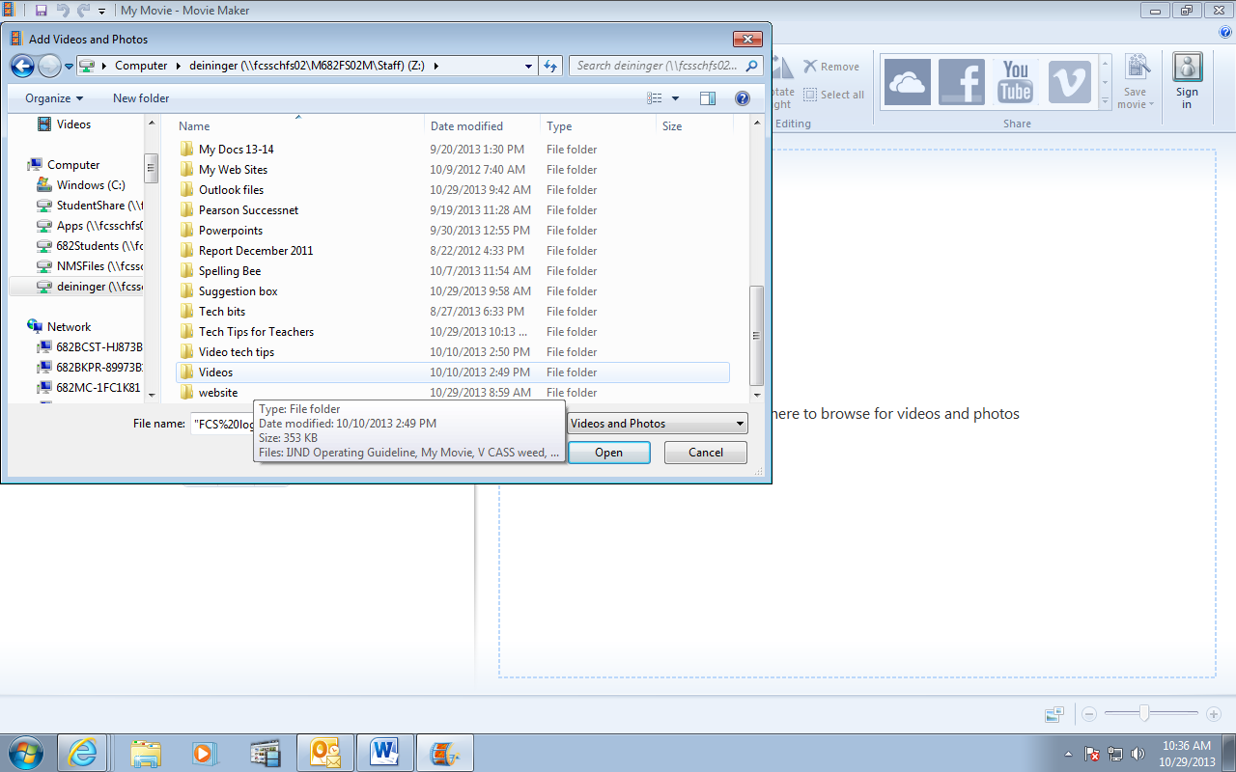

You can also add videos and pictures from a flash drive or directly from a camera.

You can add as many video clips and pictures (any combination of the 2) in any order because you can drag the clips and pictures into whatever order you want later.

Once you’ve added your video file, a film strip will appear in the main area with a player screen on the left. You can play your video clip here with the play buttons. You can use the frame-forward and frame-back buttons to navigate frame by frame. You can also use the zoom bar at the bottom right to take a closer look at your film strip.

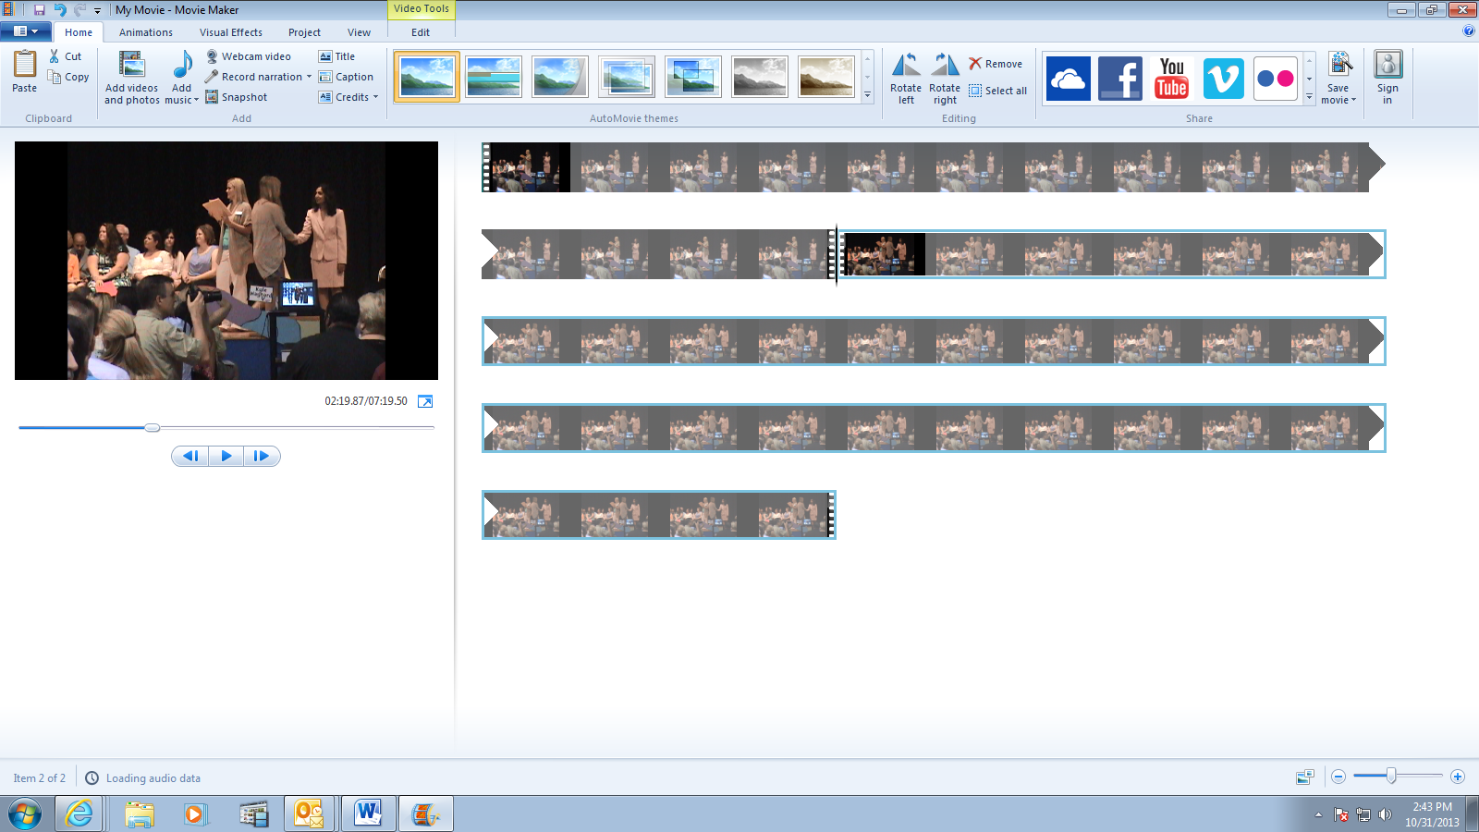

You can add more videos and pictures as you go. You can also move the video clips and pictures around to change the order.

**Editing**

The most common editing tool you will need is the **Trim tool** or the **Split**. Both can be accessed from the **Edit** tab of **Movie Maker**.



The black “scrub” bar in the center of the film strip below indicates where you are in your track, and the screen to the left of the track (not shown here) will show you what precise frame you’re looking at this part of the track.

The simplest tool to truncate a video is the **Split** tool, which simply divides one clip into two at any point of your choosing.



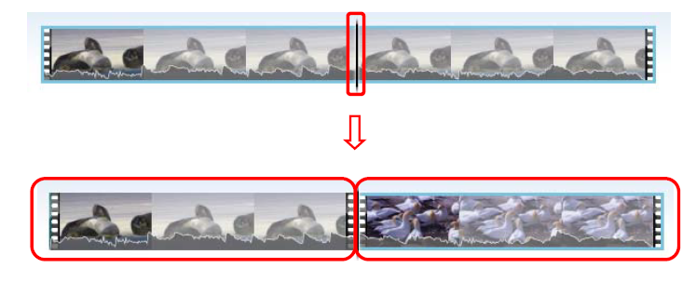

You can then edit either of these two clips independently from one another, or simply delete one of them and leave yourself only with the other.

The **Trim tool** will let you crop a smaller clip out of a larger clip, for instance when there is blank space on the front and tail end of your video clip, or if you only want to take a brief scene out of a larger video. Once again, the scrub bar and play, frame-forward and frame-back buttons can be used for precise navigation. You either can click and drag your start and end points, use the scrub bar and **Set start point** and **Set end point** buttons, or type the start and end point times in manually.



When you are satisfied with your trim, click **Save trim** to go back to **Windows Movie Maker** with your edited clip.

You can access other editing tools in the **Animations** and **Visual Effects** tabs. You can hover your mouse over these options to preview the effect on the main screen. When clipping and combining multiple clips, especially clips from different sources, or even different parts of the same source, these two features are very useful for cleaning up the presentation and making the video look more professionally done.

**Saving your movie**

Once you have made all the edits you want to make to your video clips and are ready to put the finished result into a single video file, open your main dropdown menu and go to **Save movie**. Here, you can choose which format you want your final video to be optimized for. If you want to burn your video to a DVD, you can select **Burn a DVD**. If you want to upload to a website such as your blog, you can select **For email**. If you’re not sure, you can simply select **Recommended for this project** to let Windows Movie Maker decide for you. Whichever you choose, you will be prompted to name your video and save it to your computer.



Once you’ve decided on a name, click save and wait for the video to export.

You can always use the Help function if you have questions as you’re working in Movie Maker. Here’s some more help from Microsoft.

<http://windows.microsoft.com/en-us/windows-vista/getting-started-with-windows-movie-maker>