PIXTON: Quick Start Guide

- Go to http://www.pixton.com/
- Click “Explore Now” under Pixton for Fun.

- Sign up. But when you get to the next screen don’t click “Download Now” (you don’t need to)
- Click “Create” then “Create a comic.” Choose Sunday Funny.
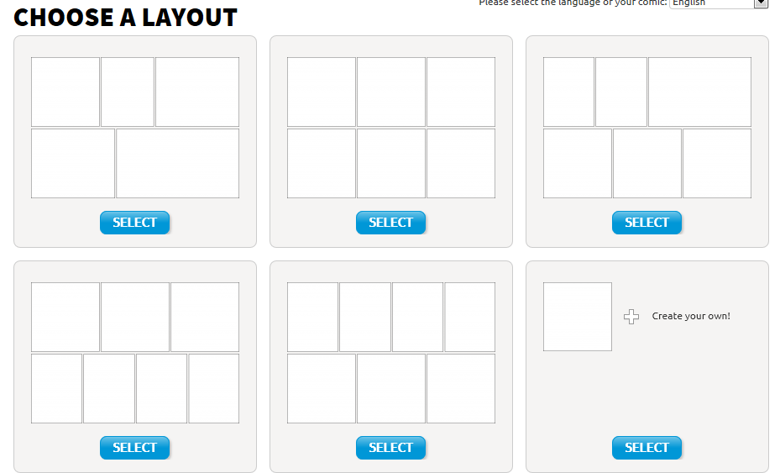
- Choose a Layout
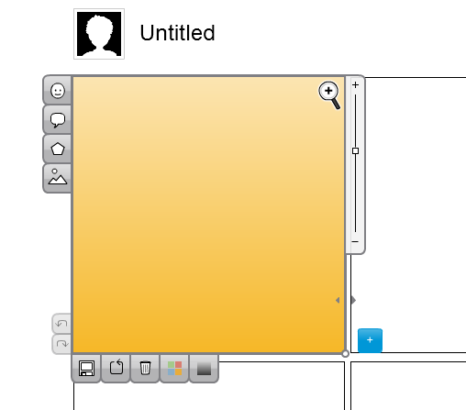
Click here to move to next panel
Choose background
Text bubbles
Choose characters
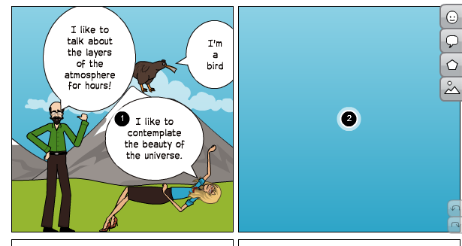

- There are helpful videos you can watch. Also just experiment. Double click on characters. Zoom in to change details in the face. Move things around….etc.

