**Glogster Quick Start Guide**

1. Go to <http://www.glogster.com/login>

Click on Sign Up

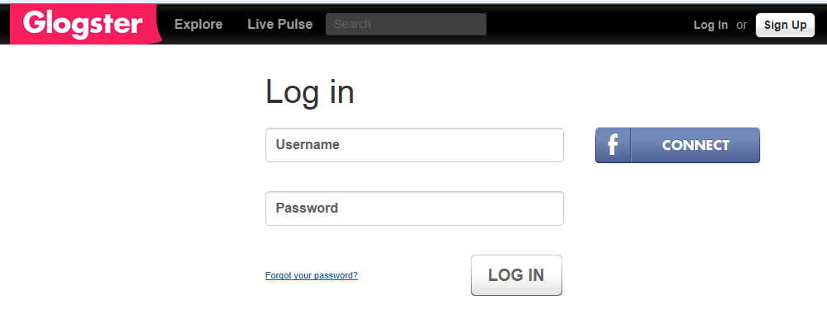

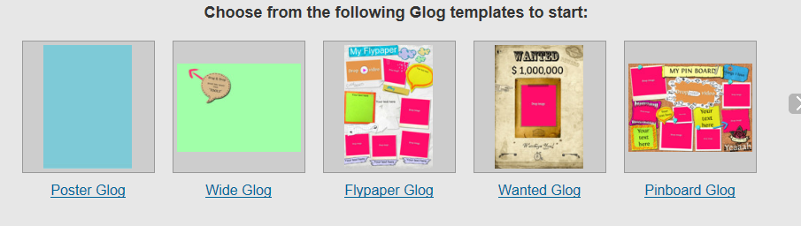

1. Choose your template.
2. Create your glogster.



Click on Tools to see all the possibilities.

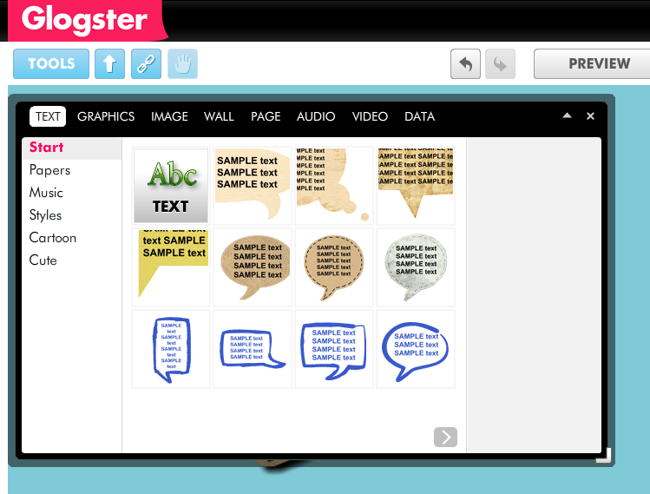

Many different options for entering text.

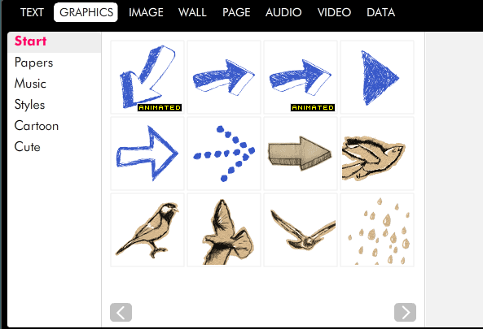

Pre-set graphics—including some animated ones.

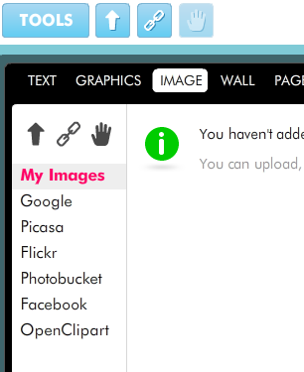

Add images from your computer or from one of these options.

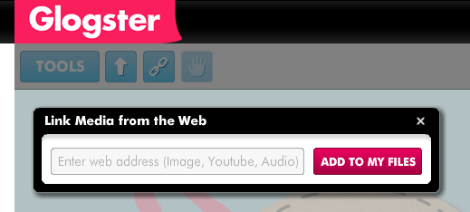

Click here to link to places on the web

2 examples of finished glogsters (you can see more online):

