Domo (Go Animate)

- Go to http://domo.goanimate.com
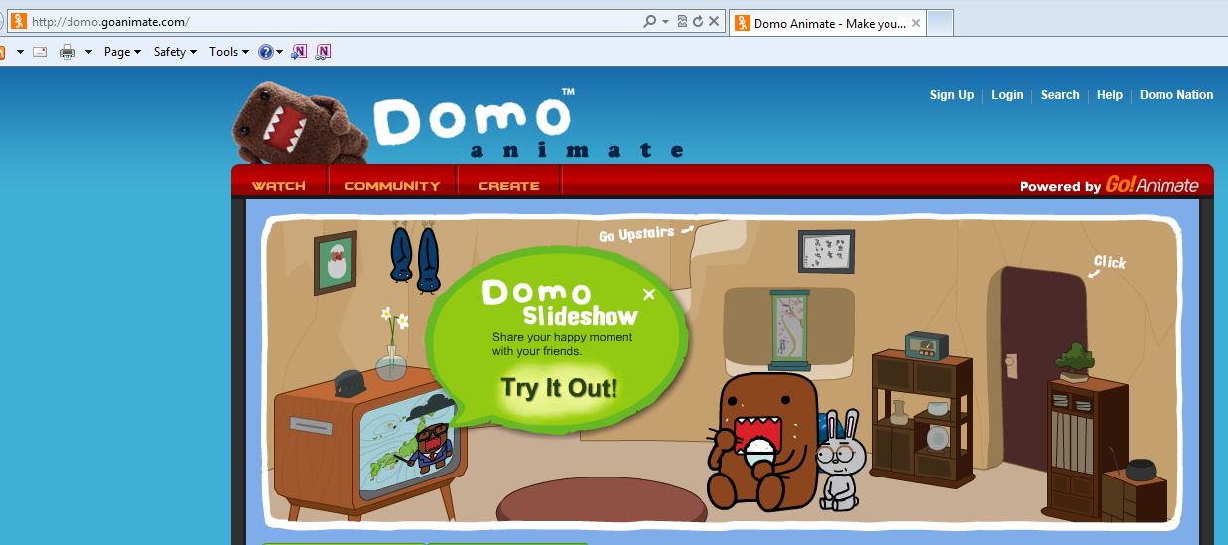
- Click on “Sign Up.”
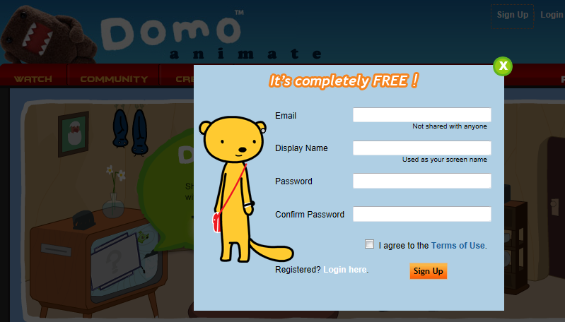
- Fill in the information and check the box next to “I agree to the Terms of Use”
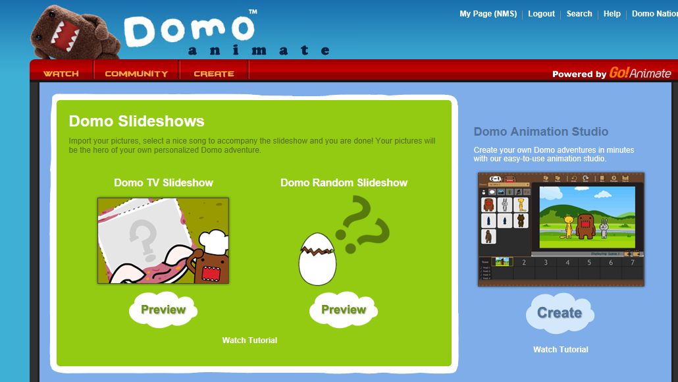
- Click on Create and you see this screen. Choose “Domo Animation Studio.”
Drop-down to show all character options
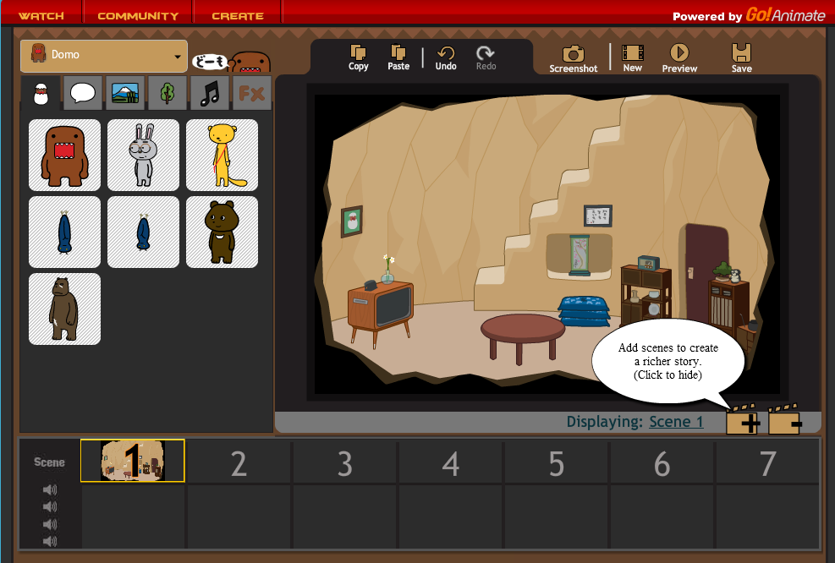
Text boxes
Background options
Characters
- Create your Domo animation!

